**Design of Android Phone Based Home Fire Alert System**



## Report Submitted for Design Lab Evaluation

*by*

## VIKRAM PATEL

**1701EE55**

*Under the Supervision of*

## Dr. Jawar Singh

Department of Electrical Engineering

Indian Institute of Technology Patna Bihar, India - 801106

March, 2021

# ACKNOWLEDGEMENTS

I would like to offer my sincere thanks to many people who helped me in the completion of this report. I must thank my Supervisor, **Dr. Jawar Singh** (Associate Professor, IIT Patna), they have been invaluable source of advice and guidance. I thank all my colleagues and friend for their help and support. I would like to give my sincere thanks to Supervisor for his patient guidance over the course of my Project. His wise and convincing suggestions always helped me out in providing right direction throughout the project.

# ABSTRACT

This project illustrates the design of a home fire alert system with Android phone and Arduino-based system by using Bluetooth Module. The project purposely is for house safety where the main motive is to avoid the fire accidents occurred in the residential areas and protect the properties inside the house as well. It utilizes Arduino Uno board in conjunction with ATmega328 chip. The main controller used is certainly the ATmega328 which controls the home fire alert subjected to the Flame sensor. A Flame Sensor is used to detect the fire. An alert message will be sent to the user via short message service (SMS) via Bluetooth module and user can control the situation by his mobile phone also. When the system detects the Fire, it will immediately display an alert notification on LCD display and simultaneously sending an SMS alert to the users after detecting the fire in the house. Results from the test are documented and discussed. Through this system, it can help users to improve their safety standards by having immediate response in preventing accidents. This will eventually allow the users to protect their lives and the properties as well from the disaster.

# TABLE OF CONTENTS

## ACKNOWLEDGEMENTS…………………………………………..……..…….1

## ABSTRACT……………………………………………………………..…….…..2

**LIST OF TABLES****…………………………………………………………………3**

**LIST OF FIGURES****………………………………………………………………..4**

1. **Introduction****……………………………………………………………………5**

1.1 Motivation…………………………………………………………………5

1. Components used………………………………………………………………6
   1. Arduino UNO……………………………………………………………..6
   2. Bluetooth Module HC-05…………………………………………..…….7
   3. Flame Sensor………..……………………………………………………..8
   4. 16X2 LCD…………………………………………………………………8
   5. Relay Module……………………………………………………………...9
2. Methodology and block diagram……………..………… ……………....10

3.1 Block Diagram for the Design…………………………………………………………..10

1. Results and Discussion …………………….……………………………..11

**Arduino Code…………………………………………………………………..13**

**Reference……………………………………………………………………….13**

**LIST OF FIGURES**

2.1 The Arduino UNO board ……………………….….……………….6

* 1. Bluetooth Module (HC-05). 7
  2. Pin diagram of Bluetooth Module .7
  3. Flame sensor………….…………………………………….…………8
  4. 16X2 LCD……….………………………………………………….8

2.6 Relay Module……………………………………………………. …9

3.1 Block Diagram …………………………………………………….10

4.1 Flame sensor ready Mode…….……………………..……………..11

4.2 Flame sensors detected the fire…………………………………….11

4.3 Message received by the user……………………………….……...12

# CHAPTER 1

**Introduction**

Amongst the occurred disasters happened in the resident area, fires have been known as the dangerous tragedy that could cause destruction, property and life losses. In many disasters, fires have become recurrent, destructive and most influential disasters if compared to others hazards. With the rapid development of urban construction, the occurrence probability of the great fire and other special disaster also increased year by year. Fires in the early detection and early warning are two important ways to extinguish the fire promptly and avoid great casualties and property loss. Therefore, the requirement of placing intelligent fire alert system is important within buildings especially in the buildings where contain many people inside or valuable belongings. Fires in the households are often triggered by many common factors investigated which are from cooking equipment, smoking in the house, electrical appliances, candles, curious children, faulty wiring and many more. If the fire occurs when the residents are in the house, the possibility to extinguish the fire is a bit high. It is because the residents themselves can take immediate precaution from the fire to be spread all over by using fire extinguisher or call the fireman instantly. The main concern of this project is when the residents are not at home or are not aware of the existence of the fire in the house. Having said that, the home fire alert is purposely designed to alert the house residents whenever any possibilities for having fire disaster prompted in their house. For this project, the development of home fire alert is built based on Arduino board as the main controller board that interacts with Bluetooth module which works in the communication part. The interaction is for the user to know the current situation in the house. This system works totally on wireless network communication as Bluetooth module is performed by sending an SMS to the user. The microcontroller inside the Arduino board is used as the mastermind of the circuit where it controls the circuit flows and execute all the decision as well. The Bluetooth Module is responsible for the communication part of the circuit. It takes information from the Arduino on where to send information and what information needs to be sent. It uses a Arduino tooth app for communication purposes. It is basically just a modem which uses serial communication to interface with and needs Hayes compatible AT commands for communicating with the Arduino. As soon as fire is detected an SMS will be sent to the recipient’s phone from the Bluetooth module for giving information to the user upon fire detection in the house.

**1.1 Motivation**

Residents themselves can take immediate precaution from the fire to be spread all over by using fire extinguisher or call the fireman instantly.

Residents can control the situation by his phone also.

The home fire alert is purposely designed to alert the house residents whenever any possibilities for having fire disaster prompted in their house.

The main concern of this project is when the residents are not at home or are not aware of the existence of the fire in the house

# CHAPTER 2

**Components Used**

**Main Components:**

* Arduino Uno
* Bluetooth module HC-05
* Flame sensor
* 16x2 LCD
* Relay Module
* DC fan
* Breadboard
* Connecting Wires

**2.1 Arduino UNO**

**Arduino Uno** is a microcontroller board based on the ATmega328.

Since Arduino is the main board, microcontroller on it which is ATmega328 is used as the main controller to manage the circuit accordingly. It is a well-known open-source microcontroller-based kit for creating digital devices and interactive tool that can interact with LEDs, LCD display, switches, buttons, motors, speakers and many more. The Arduino has 14 digital input/output pins (of which 6 can be used as PWM outputs) and 6 analog pins that can be integrated to many other boards and circuits which absolutely have different functions in a design. Arduino board provides a USB serial communication interfaces for loading the codes from computer. To do the codes, Arduino has prepared its own software called integrated development environment (IDE) which completely supports C and C++ programming languages. Figure 1 shows the Arduino UNO board that is used throughout the project.

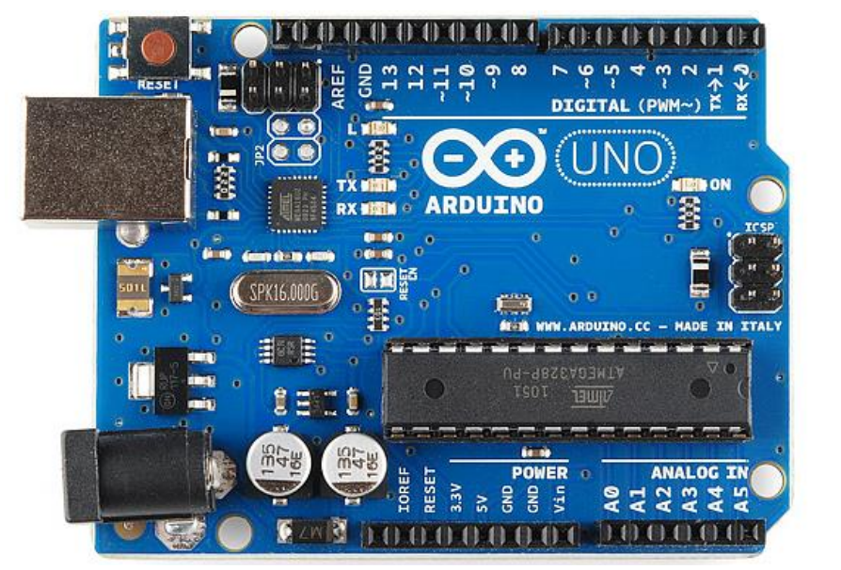

**Figure 2.1: The Arduino UNO board which uses microcontroller ATmega328 onboard**

**2.2** **Bluetooth Module HC-05**

The **HC-05 Bluetooth Module** is a very cool module which can add two-way (full-duplex) wireless functionality to your projects. You can use this module to communicate between two microcontrollers like Arduino or communicate with any device with Bluetooth functionality like a Phone or Laptop. There are many android applications that are already available which makes this process a lot easier. The module communicates with the help of Arduino tooth at 9600 baud rates hence it is easy to interface with any microcontroller that supports USART. We can also configure the default values of the module by using the command mode. So, if you looking for a Wireless module that could transfer data from your computer or mobile phone to microcontroller or vice versa then this module might be the right choice for you. However, do not expect this module to transfer multimedia like photos or songs.

The HC-05 has two operating modes, one is the Data mode in which it can send and receive data from other Bluetooth devices and the other is the AT Command mode where the default device settings can be changed. We can operate the device in either of these two modes by using the key pin according to the pin description.

It is very easy to pair the HC-05 module with microcontrollers because it operates using the Serial Port Protocol (SPP). Simply power the module with +5V and connect the Rx pin of the module to the Tx of MCU and Tx pin of module to Rx of MCU as shown in the figure 2.2.

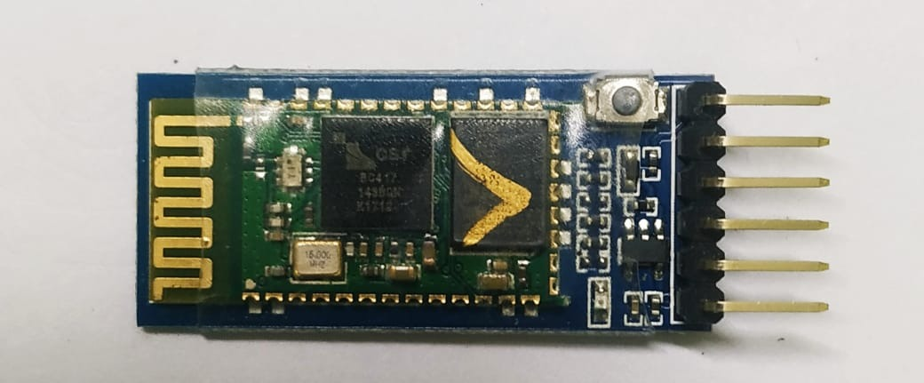

**Figure 2.2: Bluetooth Module (HC-05)**

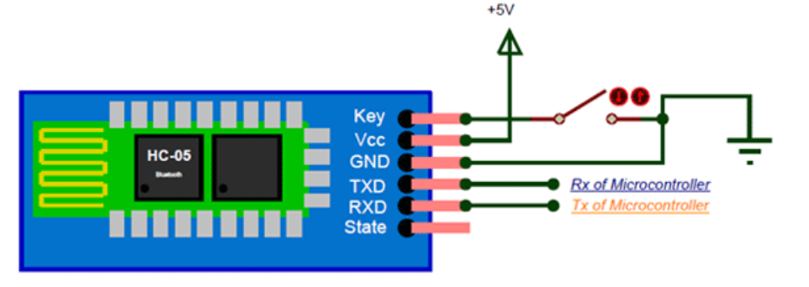

**Figure 2.3: Pin Diagram of Bluetooth Module (HC-05)**

**2.3: Flame Sensor**

A flame-sensor is one kind of detector which is mainly designed for detecting as well as responding to the occurrence of a fire or flame. This sensor/detector can be built with an [electronic circuit](https://www.elprocus.com/top-10-simple-electronic-circuits-for-beginners/) using a receiver like electromagnetic radiation. This sensor uses the infrared flame flash method.

* Pin1 (VCC pin): Voltage supply rages from 3.3V to 5.3V
* Pin2 (GND): This is a ground pin
* Pin3 (DOUT): This is a digital output pin (MCU.IO)

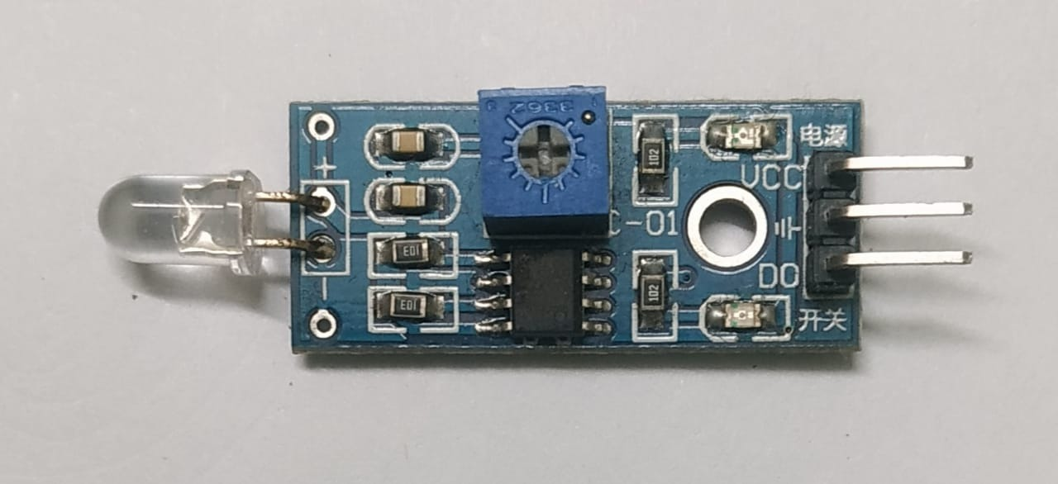

**Figure 2.4: Flame Sensor**

**2.4: 16X2 LCD**

An LCD (Liquid Crystal Display) screen is an electronic display module and has a wide range of applications. A 16x2 LCD display is very basic module and is very commonly used in various devices and circuits. A 16x2 LCD means it can display 16 characters per line and there are 2 such lines.

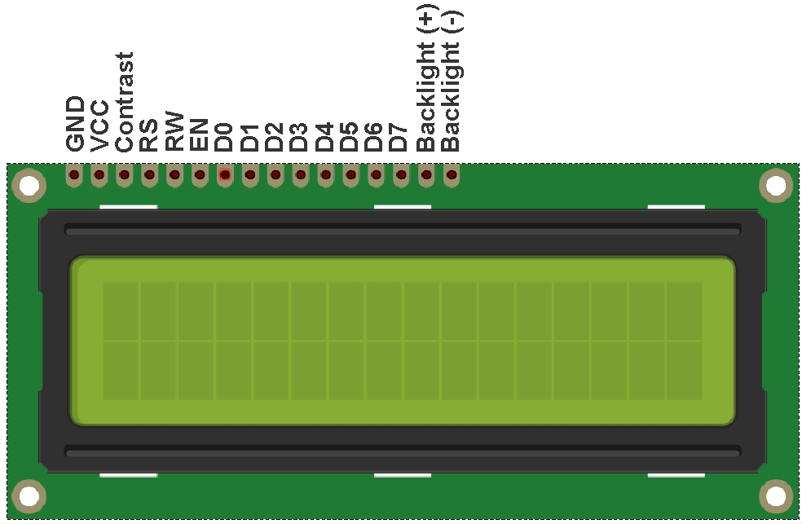

Uplink implementation of NOMA is slightly different than the downlink. Figure 2.6 depicts a network that multiplexes K UEs in the uplink using NOMA. This time, BS employs SIC in order to distinguish the user signals.

**Figure 2.5: 16x2 LCD**

**2.4: Relay Module**

A power relay module is an electrical switch that is operated by an electromagnet. The electromagnet is activated by a separate low-power signal from a micro controller. When activated, the electromagnet pulls to either open or close an electrical circuit.

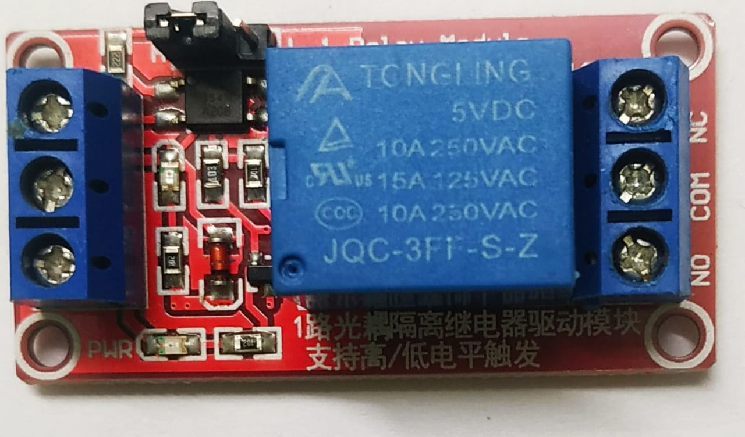

Figure 2.6: Uplink NOMA

In the uplink, the received signal by the BS that includes all the user signals is written as

**Figure 2.6: Relay Module**

# CHAPTER 3

**Methodology and Block Diagram**

When the system begins, Flame sensor will always sense the surrounding Fire. Whenever a Fire is detected, microcontroller on the Arduino UNO board will notify the Bluetooth Module (HC-05) to send an alert message to the user. And a message displayed ON the LCD connected with Arduino also.

Now relay will be on and connected fan/Volve will be also switched on.

For user convenience I have provided an extra feature to it. The user can manually check the fire condition using android. I have programmed the Arduino such that whenever the flame detected the fan/Volve will be switched on automatically and a alert also will be sent to the user.

**3.1 Block Diagram for the Design**

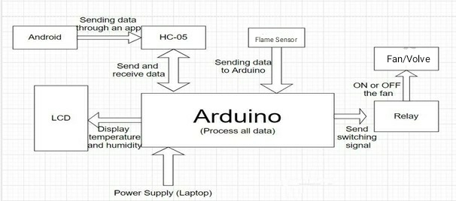

**Figure 3.1: Block Diagram for the Design**

# CHAPTER 4

**Results and Discussion**

Few tests were done to observe the system’s performance. The tests were completed by putting a candle near to the Flame sensor. Figure 7 shows the condition which the flame sensor is in ready mode (ready to detect fire but detect none). Figure 8 displays when the sensor detected fire and alert message will appear on the LCD display.

Figure 9 reveals the SMS received by the user when fire alert is notified by the system.

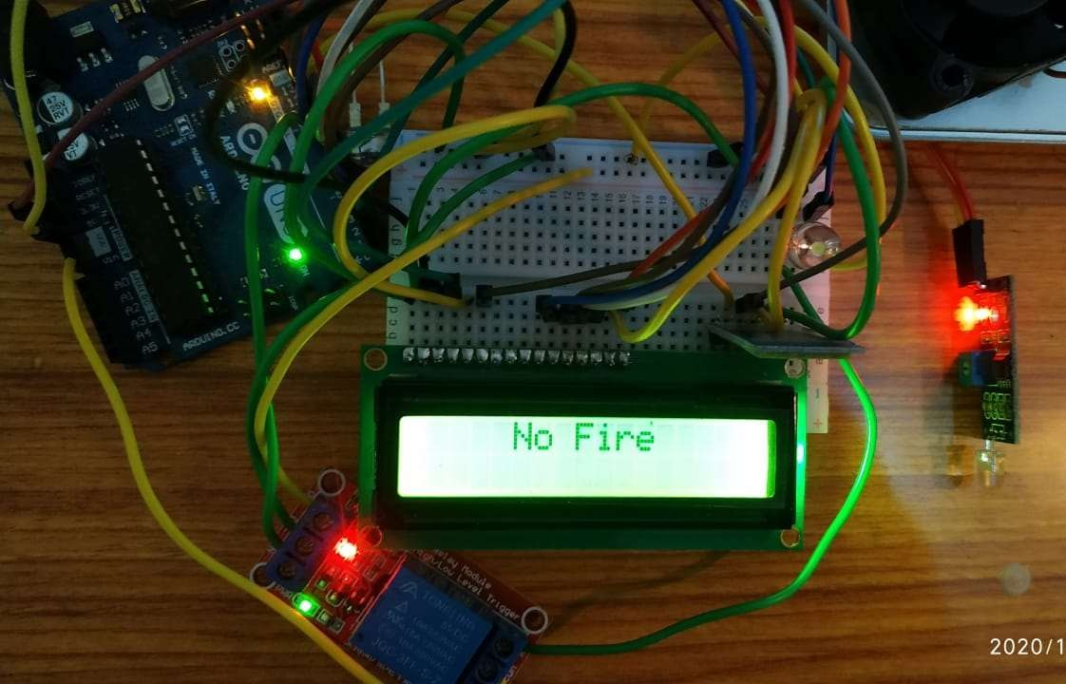

**Figure 4.1: Flame sensor ready but no fire detected**

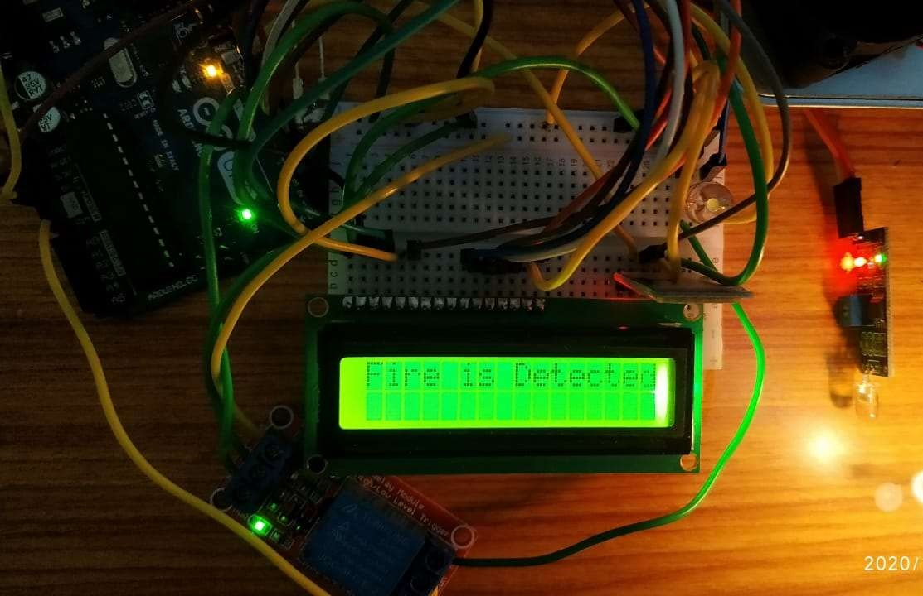

**Figure 4.2: Flame sensor detected the Fire**

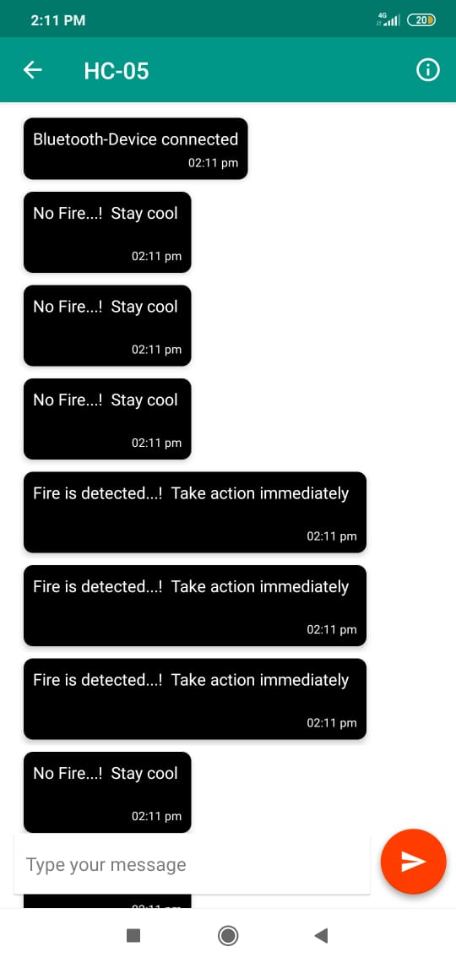

**Figure 4.3: Message Received by the user**

[**Video link for demonstration**](https://drive.google.com/file/d/1pvMhH67YDJyCoz_I3hax7vbssmGqSoLu/view?usp=sharing)

**ARDUINO CODE**

#include <LiquidCrystal.h>

#include <SoftwareSerial.h>

#define flamePin 12

LiquidCrystal lcd(2, 3, 4, 5, 6, 7);

SoftwareSerial BTserial(10, 11);

String BT_input;

int relay = 8;

void setup()

{

Serial.begin(9600);

BTserial.begin(9600);

lcd.begin(16, 2);

pinMode(flamePin,INPUT);

pinMode(relay,OUTPUT);

digitalWrite(relay,HIGH);

delay(300);

lcd.clear();

}

void loop() {

int Flame = digitalRead(flamePin);

if (Flame == LOW)

{

lcd.setCursor(0, 0);

lcd.print("Fire is Detected");

BTserial.println("Fire is detected...! Take action immediately ");

BTserial.print(";");

Serial.println("Fire is Detected..! Take action immediately");

digitalWrite(relay, LOW);

}

else

{

lcd.setCursor(0, 0);

lcd.print(" No Fire ");

BTserial.println("No Fire...! Stay cool");

BTserial.print(";");

Serial.println("No Fire...! Stay cool");

digitalWrite(relay, HIGH);

}

delay(1500);

lcd.clear();

}

# REFERENCES

1. Mahzan, Najwa & Md Enzai, Nur & Zin, N & Noh, K. (2018). “**Design of an Arduino-based home fire alarm system with GSM module**”. Journal of Physics: Conference Series. 1019. 012079. 10.1088/1742-6596/1019/1/012079.
2. K Sen, J Sarkar, S Saha, A Roy, D Dey, and S Baitalik, “Automated Fire Detection and Controlling System,” Int. Adv. Res. J. Sci. Eng. Technol., vol. 2, no. 5, pp. 34–37, 2015.

# 